Database Tuning Project
G22.2434 – Fall 2005

Ilya Finkelshteyn
NetID if276
Introduction

This paper will discuss specific database tuning methods that were applied to an existing system. I will first describe the existing system design, purpose and usage, as well as hardware characteristics. Then I will go over the tuning goals and constraints specified by the business users of the existing systems. Finally, I will list and describe each tuning technique applied, and its result on the overall system.

About the Data and Primary Application

The data consists of client trade data and contains various timestamps corresponding to the client’s investment process and trade size and execution price. The application is a 3-tier web-based application, consisting of 2 clustered web servers, 4 clustered application servers, where all computation and data enrichment is handled, and backend database. The application processes client data by enriching it with market data available at each of the timestamps provided, and computing various analytics for each trade. The results are stored in one wide record in the main Report table, and most updates/inserts are done via bulk loads. As the application grew, for performance and maintenance reasons (staggered backups, data migrations per client, etc) the database was partitioned into several (18) identical in structure Sybase ASE databases segregated by client or by region – NorthAmerica, Europe, Asia, etc, and the application enhanced to direct each client’s data into an appropriate database. In addition, as the system (and data) grew, to improve reporting performance, certain clients (data) were moved to yet another database- Sybase IQ. Currently, over 60 % of all data resides in IQ. The same online application is operating on the data, regardless of where it resides, since the schemas are identical and most operations are straight data loads.
The reporting (and what the clients really see) aspect of the application generates fixed, parameterized summary and detailed reports for up to 3 analytical measures as requested by the client. The reporting cycle is run off the production database, immediately following the completion of nightly client data loads and backups.

About the data warehouse and the ETL process

The data warehouse was necessary for two reasons – more flexible reporting at a client level (more measures, different views of the data ,etc) and ability to do macro-level reporting, allowing a comparison of each client to the whole universe of trades processes.
The data warehouse was designed to facilitate both of those goals: the design calls for a detailed trade table similar to the main table in the application, and two additional major tables – an aggregate table that stores orders (aggregated trades), and an normalized analytics table, allowing to store as many analytical calculations per trade as necessary. The data warehouse database is Sybase IQ.
The ETL process (Informatica) retrieves the data from the Application databases (IQ and ASE, which, again have identical schemas) and Market Data databases, and after some data cleaning, data enrichment and transformations, loads them into the data warehouse.

Application DB

DW - IQ
ASE
IQ

Informatica ETL
(same process for all source databases)
Reporting Engine

Tuning Goals and Constraints

In order to accomplish the goals outlined in the previous section, the data warehouse must have the most current data – namely yesterday’s data. This is impossible in the current state, due to the narrow window available for data reads from the source databases – currently about 2 hours, while one ETL cycle takes 6hrs on the average. Because of this constraint, the data warehouse is refreshed/updated on a weekly basis – starting on Saturday morning, and running for approximately 40 hours – (Weekdays average 7 hours, Saturdays average 4 hours, and Sundays average 1 hour) – finishing Sunday night. And hence the reason for tuning this ETL process.
Another effect of such a long-running load process is the inability to reload the whole data warehouse (2 years) in any reasonable timeframe. So the goals as specified by the business group were 2-fold – speed up the data loading process to enable capture of yesterday’s data by the following morning, and then leave sufficient time to run reports (2-3 hours) and to enable reloading of the whole dataset, if necessary due to changes in requirements, in a reasonable timeframe – (a few weeks was deemed reasonable – but given the current state, no hard requirement was posed)
A few constraints were reiterated: The schema of the source databases can not be changed, due to the primary online application accessing it, and there should be no impact to performance, access or availability of the online application due to reads performed by the ETL process.

Current System Specification
Source (operational databases)
A number (18) of ASE databases co-residing on a single server
- Main data table (Report) ranging from 1 Million to 8 Million rows
- Time/Date dimension tables
- ~30 lookup tables (< 100 rows)
Hardware / OS
- Solaris
- 4-CPU x 900GHz 4 Gb Ram
- Sun StorEdge A5200, 1TB of space using 73Gb/10000rpm disks, partitioned into two logical partitions; DB on one, Log on another

Sybase IQ 12.5 Database
- Main data table, 86 Million rows
- Time/Date dimension tables
- ~30 lookup tables (< 100 rows)
Hardware / OS
- Solaris
- 4-CPU x 1.2GHz 16 Gb Ram
- Sun StorEdge A5200, 1TB of space using 73Gb/10000rpm disks, partitioned into two logical partitions; DB on one, Log on another

Target (data warehouse)
Sybase IQ 12.5 Database
- 3 Main data tables (Orders, Trades, Analytics) 40 M rows, 100 M rows and 250 M rows respectively
- 5 Market Data tables, 40 M rows average (loaded separately)
- Time/Date dimension tables
- ~30 lookup tables (< 100 rows)
Hardware / OS
- Solaris
- 4-CPU x 900MHz 4 Gb Ram

Tuning approach and results

Given the scope of this project, and relative flexibility allowed in terms of approach, I decided to look at the tuning at all levels, including hardware, data partitioning and query and index optimization, and apply it at both the source systems and the target system.

Starting point: Each source DB is processed separately: data of interest (added or updated within a particular time frame – usually a day) is read from the main (Report) tables into a staging table in the data warehouse. Then, based on business rules, some items are removed, and subsequently read from that table, transformed and inserted into 3 separate tables in the data warehouse. Note that each insert is really a load – ready data is first written out to disk as a flat file, and then bulk loaded.
The overall ETL process time is split between the extract part (35%), the load part (60%), transform (3%) (done in memory and very fast) and the last 2% is spend on workflow/session startup and logging in Informatica. However, this data was a little deceiving, because about twice (2) a week the extract portion from one of the ASEs would take 3 hours longer than usual, so on those days the timings were reversed.

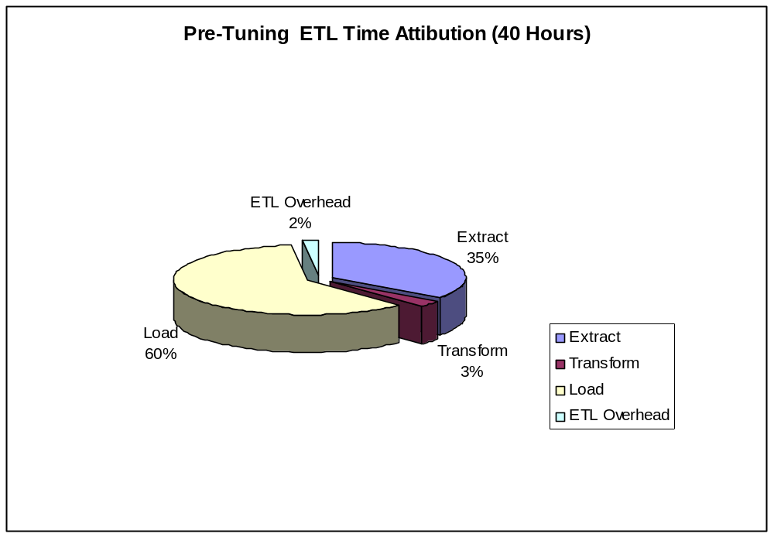

System Resource utilization (Memory and CPU)

Sources: CPU was showing very low percent utilization, on the ASE machine. Memory utilization was not changing during the ETL process at all, and was not maxed out. On IQ source, CPU was spiking to 70 % periodically, but mostly holding at low percentage, while memory utilization was fairly static at 4 GB, well within the available memory
Target: During the load, CPU held at 80-100% utilization, showing a fairly high utilization, confirming the fact that IQ is very CPU intensive for both data compression / decompression and Index management. Memory utilization was static at 3 GB, well within the available memory. However, it seemed that IQ just grabbed that memory from the start, and it was not related to the load.

Speeding up loads

Source Data availability: One of the constraining factors was the availability of the source systems for read, not to interfere with the other functionality (data loads, backups and online access). A simple but very effective way to address this, while providing the same functionality was to streamline the backup schedule, and redirect the reads to the Disaster Recovery site, used to be ‘cold’ but now will be ‘warm’, which was loaded with the nightly backup. The advantage of reading from DR is so that it allows me to read as long as I need, so I can do complete data reloads, and it adds a safety net n terms of running a little later with the ETL process does not affect production. The disadvantage here is that the earliest this site was available is 6 am the following morning, which now adds a constraint that both the ETL process and the reporting cycle needs to complete with 3 hours (but some reports are needed by 8 am) to be ready by 9 am. The feasibility of this item depends on other optimizations.

Target data warehouse hardware: Sybase IQ is much more CPU intensive as compared to a regular DBMS (such as Sybase ASE) (because of index usage and data compression/decompression). I expected that a boost in CPU speed/performance would have a significant impact on both load times and query performance of the Data Warehouse. In addition, we decided to move to a 64 bit Linux OS, which Sybase recommended as one of the best configurations. This proved to be true – a new server for the data warehouse produced a tremendous improvement in speed – shaving off 14 hours (37 % improvement) from the weekly load, an average of 2.5 hours from a weekday and 0.5 hour from Sun and Mon. load.
Side Note: It would be interesting to see what percentage of the gain was due to the move to the new hardware, and what was due to the 64 bit OS.

Sybase IQ 12.6 Database
Hardware / OS
- Linux 64 bit OS
- 2-CPU Dual Core x 2.4 GHz 16 Gb Ram

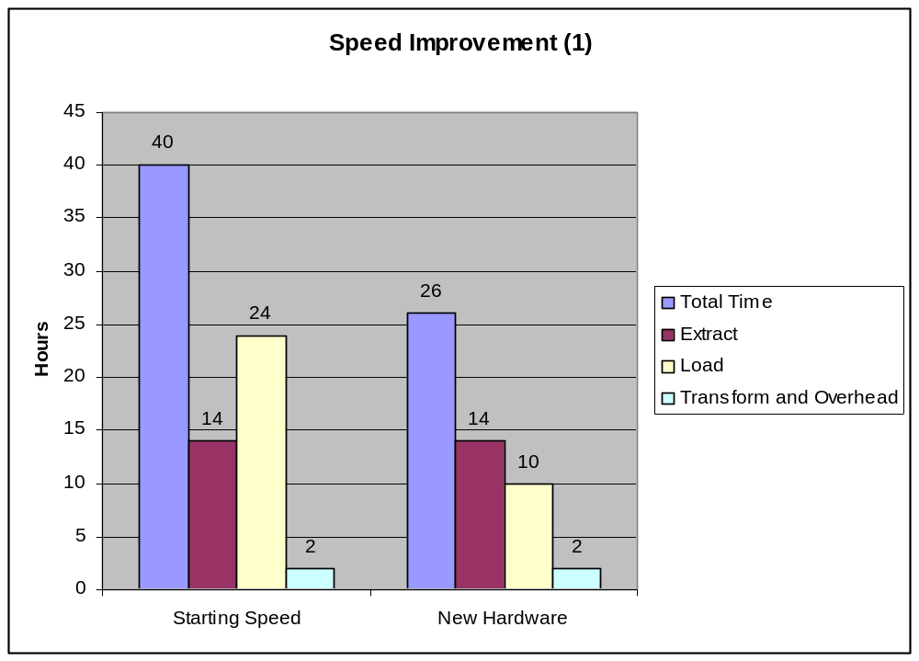

Dropping indexes: I first looked at all existing indexes in the data warehouse. Besides the default indexes on each column, which Sybase IQ creates, there were a number of other indexes which were created by the original designer of the system, assuming certain usage. I went through them one by one, deciding if the index was ‘correct’ – based on actual usage, as well as Sybase’s recommendations for IQ indexes. I found a significant number of indexes: 8 on Order table, 12 on Trade table, and 5 Analytics table which were both not meaningful and incorrect based on Sybase’s docs – HG indexes on columns containing double or float data.
I dropped these, and saw an immediate performance gain of 6 hours over 1 week’s data
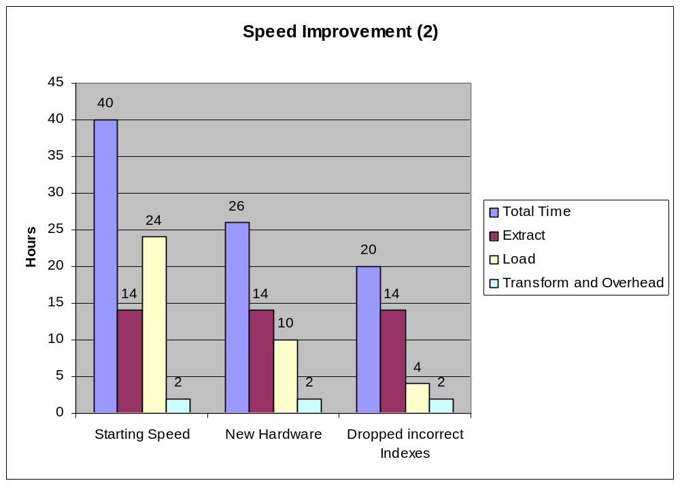

Load Queries: The load process would first remove existing records from the target tables that were about to be loaded from the staging table. These queries were taking a long time, even though both the staging and the target tables were indexed on the join columns, and the delete data set was relatively small. This was perhaps the most interesting and difficult to find problem. Once query plans were generated using the index advisor (only available in IQ 12.6) I discovered that the indexes were not being used because the data types were slightly different (numeric vs. integer) on StageReport table and Order, Analytics, Trade tables. The data was an integer, but in staging table it was defined as numeric! Once I changed the data type of the columns involved in that join, I saw an improvement of 1.5 hours over the one week’s data loads.

Additional Indexes: Few more indexes were tried with little or no improvement for the queries, but a slowdown of the loads. Given the tradeoff, I left them out for now.

At this point, the combined load step is taking less than 2.5 hours for 1 week’s worth of data loads
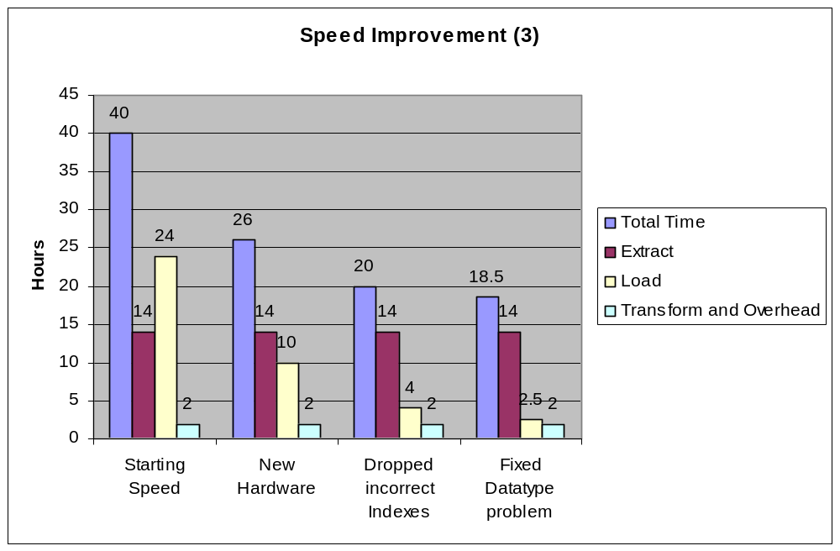

Reporting Query: Most reports from the data warehouse needed to join Trade with Order or Analytic or both tables. In an attempt to improve that, I added a special IQ index - Join Index - to those tables. I saw a very small degradation of performance of loads, and a minor improvement in typical query from the Data warehouse – reducing the time by about 1-2 minutes. Since of the existing reports take approximately 5-7 minutes, with time spent retrieving the data, formatting and generating a PDF document. I could not get a more accurate measurement at this time. I decided to keep the Join Index in place, and reexamine it in the future.

Speeding up reads

Source databases hardware: No changes were allowed to this hardware at this point, not to disturb the existing system.

Adding Indexes: Periodically, I would see a tremendous degradation (spike) in the read performance from an ASE –based database. It was attributed to one particular lookup query. Under normal conditions, it was taking 2-10 minutes, but periodically would spike up to 3.5 hours. It appeared that if the number of rows retrieved was greater that 7-8 K, the performance degraded tremendously – likely because it would no longer be able to do join in memory. I took a look at the existing indexes in the source system (ASE), and realized that my query would benefit from an additional index. After consulting with the DBA and the project manager of the online system, this additional index (on TableX, columns id1, id2 in ASE) was deemed safe and even somewhat useful for the online system as well, and it was added to the system. The result was phenomenal. The query performance went from 3-4 minutes average, sometimes peaking at 3.5 hours down to a consistent 18 seconds! Total savings of approximately 8 hours over one week’s data loads (two spikes-> 7hs savings, + 3 minutes * 20 ASEs)
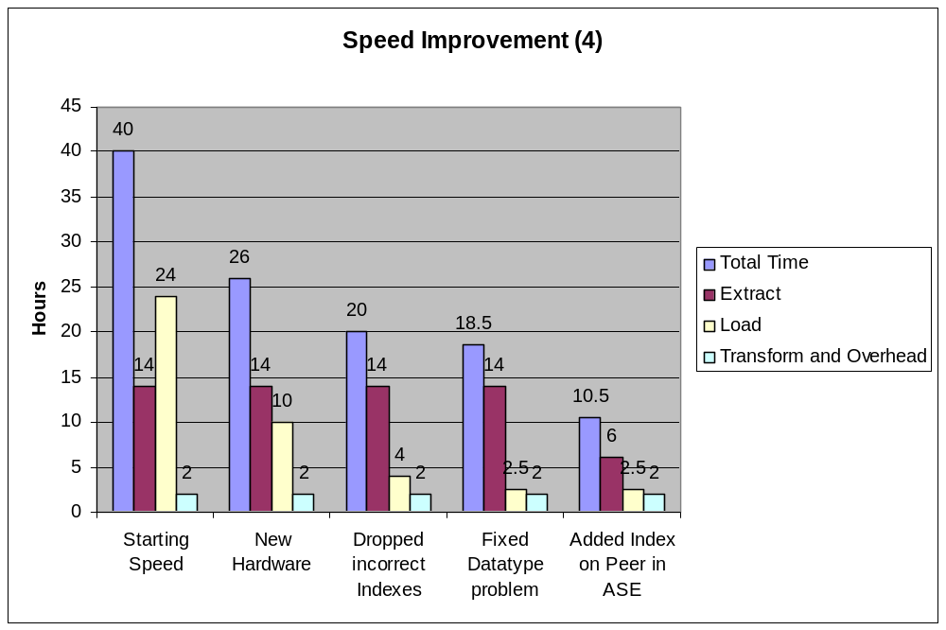

Detailed explanation below:
Detail is just a named temp table in this case, so no indexes apply to it, but the TableX (name changed) is a real table, so the additional index on TableX (id1, id2) was beneficial on ASE. On IQ, this was not necessary – IQ already had a HG index on id1 and an HG index on id2

Select max(A), sum(B), … from TableX,
(select distinct Detail.id1, Detail.id2,
Detail.f3, Detail.f4
from Detail
where ((timestamp between '2003/11/24 00:00:00'
AND '2003/11/25 00:00:00') OR
(lastUpdated between '2003/11/24 00:00:00'
AND '2003/11/25 00:00:00')) ) Detail
where TableX.id1 = CAReportDetail.id1
and TableX.id2 = Detail.id2
group by TableX.id1, TableX.id2,Detail.f3, Detail.f4
order by TableX.id1, TableX.id2,Detail.f3, Detail.f4

Query re-writing: This optimization was a result of looking at this query’s Plan. The main select query from the source systems was taking approximately 3 minutes to run for the IQ-based database. Once analyzed using a query plan, I noticed that the selection criteria used

((timestamp > '2003/11/24 00:00:00' AND
timestamp < '2003/11/25 00:00:00')
OR
(lastUpdated > '2003/11/24 00:00:00' AND
lastUpdated < '2003/11/25 00:00:00'))

was not evaluated as a range query, but was broken up into four sub-selections based on the time. This seemed like a clear but in the query parsing module. Once I rewrote the query using a between clause

((timestamp between '2003/11/24 00:00:00' AND
'2003/11/25 00:00:00')
OR
(lastUpdated between '2003/11/24 00:00:00' AND
'2003/11/25 00:00:00'))

the query plan became normal, and the appropriate index was now used for the range query. After further testing, I narrowed down this issue to a case with an OR in the where clause – without the OR, either version was correctly interpreted as a range query.

This query re-writing reduced the selection time from 3 minutes to 15 seconds, saving 2:45 minutes off every extraction cycle from IQ – not a whole lot, but a huge improvement percentage-wise. I also tested this change on the ASE databases, and it had no impact, since the original query was interpreted correctly as a range query.

Note: after IQ 12.6 came out, I retested this in our development environment, and the query plan was now identical (using a range) for both versions of the query. However, I did not find this fix in their release notes though ☺

Source Data Partitioning: The online application was already set up to allow the data to be partitioned into separate database instances without changing any application code. This proved useful as further partitioning – EuropeDB was partitioned to EuropeDb1 and EuropeDb2, and NorthAmerica was partitioned into NA1, NA2 and NA3 which allowed for faster queries of data. While this solution is of a band-aid type, hiding inefficiency in indexes and/or queries, but it worked well enough, without a lot of effort being put in to making it work. The improvement in the partitioned ASE databases (which I had to benchmark separately) was as follows:

The extract part for the now 5 ASEs took 2.5, as compared to for the original two 5 hours (these were some of the biggest as slowed ASE’s), and adding the extra overhead for 3 additional sessions was insignificant, the overall gain was 2.5 hours.

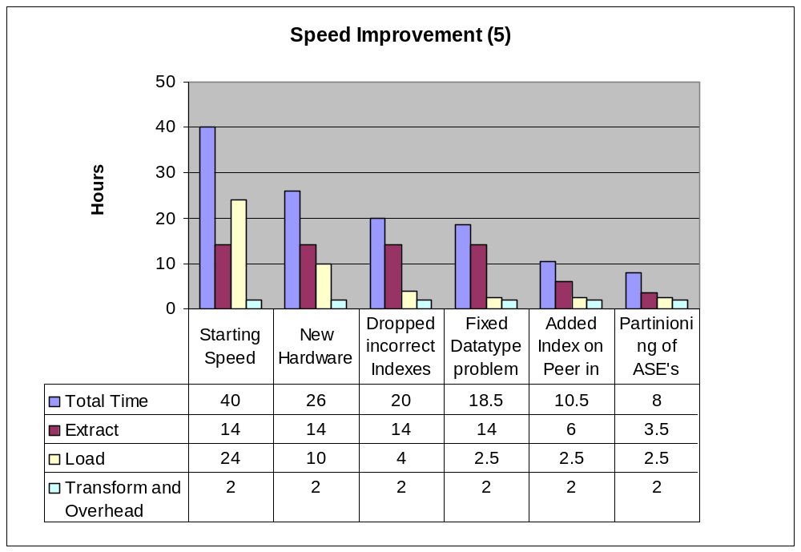

Summary

In all, the overall improvement was 5-fold, from 40 hours to down to 8 hours for a week’s worth of data. Moreover, the daily loads were now very consistent between 60 minutes and 75 minutes for weekdays (Tue-Sat runs) and 40-45 minutes for the weekends. The improvement can be attributed as follows
Improvement attribution | Time Savings per Week (hours)
Index Dropping | 6
New Hardware / OS | 14
Source Partitioning | 2.5
Data Type Mismatch | 1.5
Other | 0.5
Added Index (id1, id2) | 8
Total Savings | 32.5
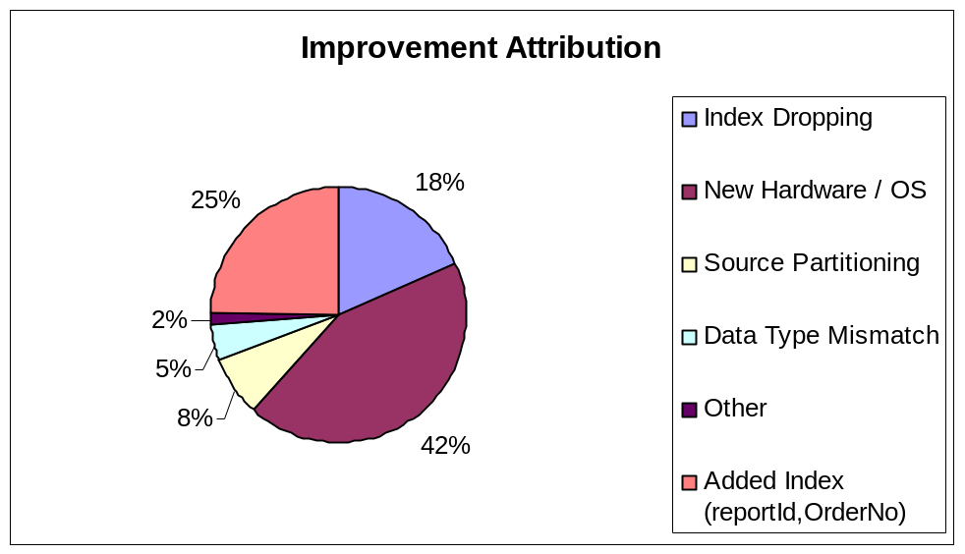

The biggest impact was the hardware, and this is due mostly to the specific functioning of the Sybase IQ and it’s demands on the CPU. With the exception of the range query bug in Sybase IQ, all other tunings had a significant overall impact. The Extract and Load phases are still the most time-consuming (see the graph below) , but Transform phase and the ETL/Informatica overhead now contribute to a significant portion of the overall process, and it would make sense to look at ways of optimizing them as well.

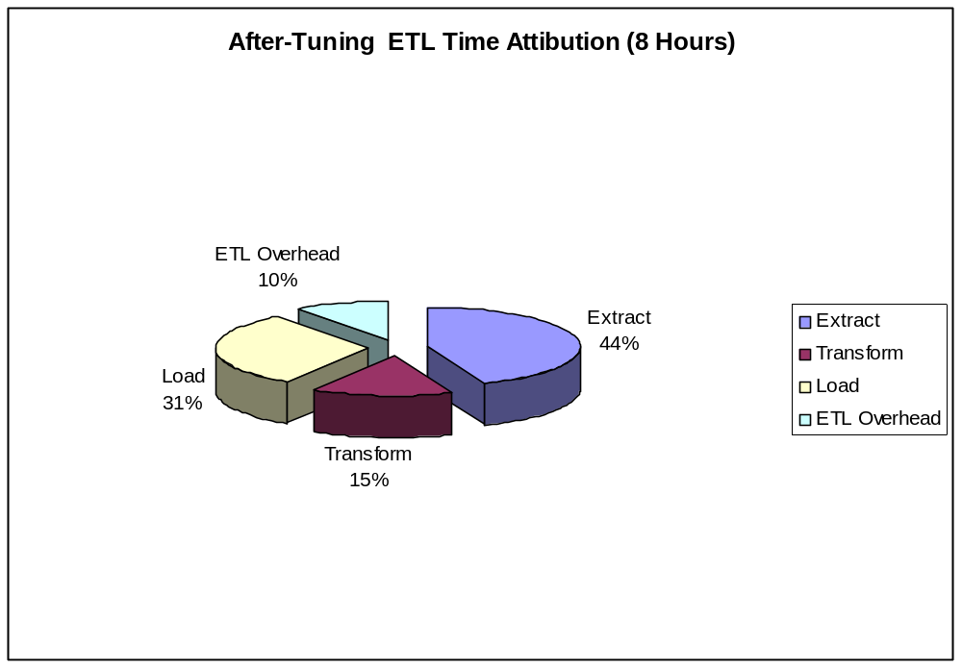

Tuning the process has allowed the ETL cycle to run daily, satisfying and exceeding both business requirements. It has also shown the value of tuning, and I feel efforts such as this will be ongoing from now on.

This is of course a work in progress, with further improvements possible. A number of interesting opportunities for improvement exists:
- For complete reloads, read and reload weeks or months at once, instead of daily, to possibly reduce Informatica overhead for starting workflows and populating lookup tables, and well as take further advantage of bulk loading.
- IQ options are being more exposed, and some are index performance related (ex. Creating the default FP indexes with Optimized Compression flag. These will need to be examined further.
- Instead of sequential processing of each separate source DB, try concurrent possessing (if the Informatica tool allows). This will save time – since reads from one source DB and writes to target data warehouse of data from another source DB can be happening simultaneously.
- Faster Disks. IO is probably the biggest contributing factor to the performance. Looking at the disk queues might provide some indicators here. The existing A5200 array is a few years old, and it would be interesting to see if newer (and possibly bigger / faster) disks can make a difference – but the budget constraints for next year may not allow for this option to be explored.
- Using index advisor, available in IQ 12.6 only, suggested additional indexes (mostly LF) which were not apparent. I will be implementing them and benchmarking the performance.
- Evaluate the performance of the Transform phase, and see if that can be improved. This would involve getting into the guts of Informatica, and figuring out if any transformations can be done faster and/or pushed to the database.
- Take a closer look at the Informatica overhead, and determine what the time is being spent on. Perhaps some logging can be reduced or streamlined, or sessions can be reused in a more efficient manner.
- Examine the reports, and determine if any improvements can be made there.
References and Bibliography

Database Tuning by Dennis Shasha and Phillippe Bonnet
Sybase IQ online manuals (http://infocenter.sybase.com/topic/com.sybase.help.iq/html)
Understanding IQ query Plans – presentation by Lou Stanton
Joe Celko – SQL for Smarties

